Lab 02 - Create Single Page Application with ReactJS

1. Introduction
This lab explores creating a Single Page Application with ReactJS. You will continue to work with the React application that you have been developing in the Lab 01 to show the list of Orchids.

2. Lab Objectives
In this lab, you will:
- Create the data of Orchids
- Created a new Orchids component and added it to your React application.
- Updated the view of the Orchids component to display the orchids (Each of information orchid includes: id, image, name, origin, color, isSpecial, rating, category), Ex:
- Complete the detail of Orchid function by using the Modal component
{
id: ‘1’,
orchidName: 'Taichung beauty',
isSpecial: true,
image: ‘https://barritaorchids.com/cdn/shop/products/Cf592_1024x1024.jpg’,
category: ‘Cattleya’
}

Activity 01: Consume React-Bootstrap via the npm package
Step 01. Install react-bootstrap and Bootstrap CSS
npm install react-bootstrap bootstrap
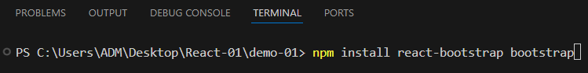
- Included CSS to your application:
{
/* The following line can be included in your src/main.jsx or App.jsx file */
}
import 'bootstrap/dist/css/bootstrap.min.css';

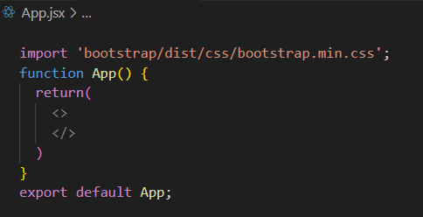
Step 02. Create the NavBar component
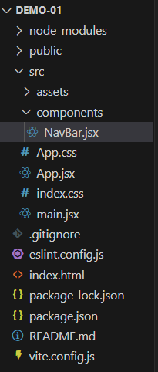
- Create a new folder components, add a new files named NavBar.jsx
- Update some code to NavBar.jsx file
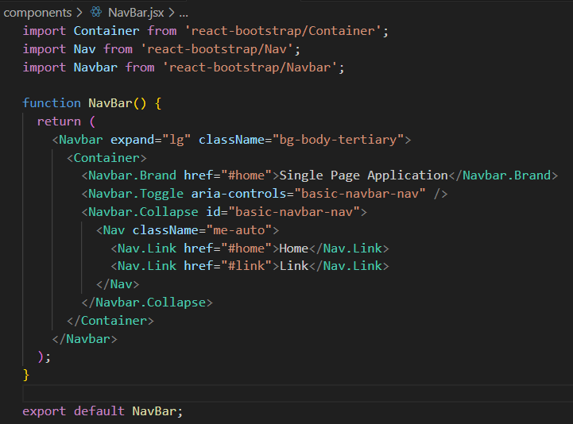

- Import the NavBar component to App.jsx file
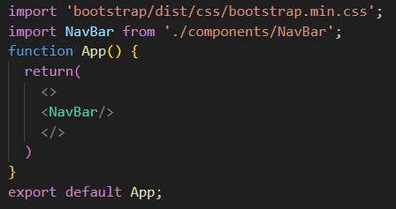
- The screen will display below:
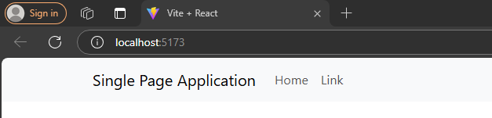

Activity 02: Design the List of Orchids component
Step 01. Create the data of Orchids
- Add a folder named shared under the src folder.
- In the shared folder, create a new file named ListOfOrchidss.js and add the following content to it
export const OrchidsData =
[
{
"id": "1",
"orchidName": "Ceasar 4N",
"description": "Lorem ipsum dolor sit amet, consectetur adipiscing elit. Nulla porta lobortis ex. Morbi cursus consectetur diam, non lobortis massa gravida eu. Duis molestie purus vel ligula suscipit, sit amet iaculis justo tempus. Cras pellentesque urna in feugiat fringilla. Vivamus dictum lacinia nulla, id rhoncus lectus fermentum et. Lorem ipsum dolor sit amet, consectetur adipiscing elit. Nulla porta lobortis ex. or sit amet, consectetur adipiscing elit. Nulla porta lobortis ex. or sit amet, consectetur adipiscing elit.",
"category": "Dendrobium",
"isSpecial": true,
"image": "images/4n.jpg"
},
{
"id": "2",
"orchidName": "Mini Yaya",
"description": "Lorem ipsum dolor sit amet, consectetur adipiscing elit. Nulla porta lobortis ex. Morbi cursus consectetur diam, non lobortis massa gravida eu. Duis molestie purus vel ligula suscipit, sit amet iaculis justo tempus. Cras pellentesque urna in feugiat fringilla. Vivamus dictum lacinia nulla, id rhoncus lectus fermentum et. Lorem ipsum dolor sit amet, consectetur adipiscing elit. Nulla porta lobortis ex. or sit amet, consectetur adipiscing elit. Nulla porta lobortis ex. or sit amet, consectetur adipiscing elit.",
"category": "Dendrobium",
"isSpecial": true,
"image": "images/yaya.jpg"
},
{
"id": "3",
"orchidName": "Crystallinum",

"description": "Lorem ipsum dolor sit amet, consectetur adipiscing elit. Nulla porta lobortis ex. Morbi cursus consectetur diam, non lobortis massa gravida eu. Duis molestie purus vel ligula suscipit, sit amet iaculis justo tempus. Cras pellentesque urna in feugiat fringilla. Vivamus dictum lacinia nulla, id rhoncus lectus fermentum et. Lorem ipsum dolor sit amet, consectetur adipiscing elit. Nulla porta lobortis ex. Morbi cursus consectetur diam, non lobortis massa gravida eu. Duis molestie purus vel ligula suscipit, sit amet iaculis justo tempus. Cras pellentesque urna in feugiat fringilla. Vivamus dictum lacinia nulla, id rhoncus lectus fermentum et. Lorem ipsum dolor sit amet, consectetur adipiscing elit. Nulla porta lobortis ex. or sit amet, consectetur adipiscing elit.",
"category": "Dendrobium",
"isSpecial": true,
"image": "images//3mau.jpg"
},
{
"id": "4",
"orchidName": "Damari",
"description": "Lorem ipsum dolor sit amet, consectetur adipiscing elit. Nulla porta lobortis ex. Morbi cursus consectetur diam, non lobortis massa gravida eu. Duis molestie purus vel ligula suscipit, sit amet iaculis justo tempus. Cras pellentesque urna in feugiat fringilla. Vivamus dictum lacinia nulla, id rhoncus lectus fermentum et. Lorem ipsum dolor sit amet, consectetur adipiscing elit. Nulla porta lobortis ex. Morbi cursus consectetur diam, non lobortis massa gravida eu. Duis molestie purus vel ligula suscipit, sit amet iaculis justo tempus. Cras pellentesque urna in feugiat fringilla. Vivamus dictum lacinia nulla, id rhoncus lectus fermentum et. Lorem ipsum dolor sit amet, consectetur adipiscing elit. Nulla porta lobortis ex. or sit amet, consectetur adipiscing elit.",
"category": "Dendrobium",
"isSpecial": false,
"image": "images/damari.jpg"
},
{
"id": "5",
"orchidName": "Busuangense",
"description": "Lorem ipsum dolor sit amet, consectetur adipiscing elit. Nulla porta lobortis ex. Morbi cursus consectetur diam, non lobortis massa gravida eu. Duis molestie purus vel ligula suscipit, sit amet iaculis justo tempus. Cras pellentesque urna in feugiat fringilla. Vivamus dictum lacinia nulla, id rhoncus lectus fermentum et. Lorem ipsum dolor sit amet, consectetur adipiscing elit. Nulla porta lobortis ex. Morbi cursus consectetur diam, non lobortis massa gravida eu. Duis molestie purus vel ligula suscipit, sit amet iaculis justo tempus. Cras pellentesque urna in feugiat fringilla. Vivamus dictum lacinia nulla, id rhoncus lectus fermentum et. Lorem ipsum dolor sit amet, consectetur adipiscing elit. Nulla porta lobortis ex. or sit amet, consectetur adipiscing elit.",
"category": "Dendrobium",
"isSpecial": true,
"image": "images/thohong.jpg"
},
{
"id": "6",
"orchidName": "Pink Moth",
"description": "Lorem ipsum dolor sit amet, consectetur adipiscing elit. Nulla porta lobortis ex. Morbi cursus consectetur diam, non lobortis massa gravida eu. Duis molestie purus vel ligula suscipit, sit amet iaculis justo tempus. Cras pellentesque urna in feugiat fringilla. Vivamus dictum lacinia nulla, id rhoncus lectus fermentum et. Lorem ipsum dolor sit amet, consectetur adipiscing elit. Nulla porta lobortis ex. Morbi cursus consectetur diam, non lobortis massa gravida eu. Duis molestie purus vel ligula suscipit, sit amet iaculis justo tempus. Cras pellentesque urna in feugiat fringilla. Vivamus dictum lacinia nulla, id rhoncus lectus fermentum et. Lorem ipsum dolor sit amet, consectetur adipiscing elit. Nulla porta lobortis ex. or sit amet, consectetur adipiscing elit.",
"isSpecial": true,
"image": "images/hodiep.jpg",
"category": "Oncidium"
},
{
"id": "7",
"orchidName": "Alba",
"description": "Lorem ipsum dolor sit amet, consectetur adipiscing elit. Nulla porta lobortis ex. Morbi cursus consectetur diam, non lobortis massa gravida eu. Duis molestie purus vel ligula suscipit, sit amet iaculis justo tempus. Cras pellentesque urna in feugiat fringilla. Vivamus dictum lacinia nulla, id rhoncus lectus fermentum et. Lorem ipsum dolor sit amet.”
"category": "Dendrobium",
"isSpecial": true,
"image": "images/alba.jpg"
},
{
"id": "8",
"orchidName": "Singapore yellow dendro",
"description": "Lorem ipsum dolor sit amet, consectetur adipiscing elit. Nulla porta lobortis ex. Morbi cursus consectetur diam, non lobortis massa gravida eu. Duis molestie purus vel ligula suscipit, sit amet iaculis justo tempus. Cras pellentesque urna in feugiat fringilla. Vivamus dictum lacinia nulla, id rhoncus lectus fermentum et. Lorem ipsum dolor sit amet, consectetur adipiscing elit. Nulla porta lobortis ex. Morbi cursus consectetur diam, non lobortis massa gravida eu.",
"category": "Dendrobium",
"isSpecial": true,
"image": "images/yellow.jpg"
}
]
Step 02. Create a new component named Orchids.jsx

- Use the react-bootstrap to design a template below:
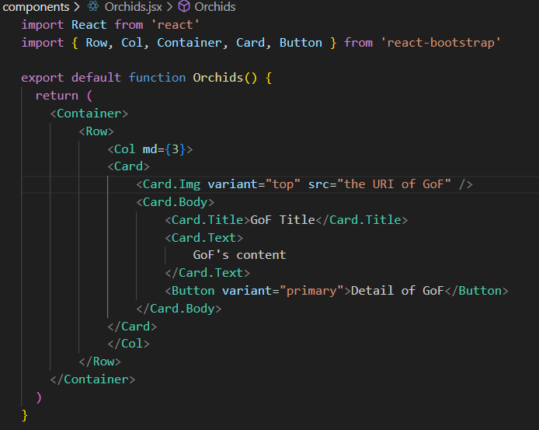

- Update somw code to show the list of Orchids to the view:
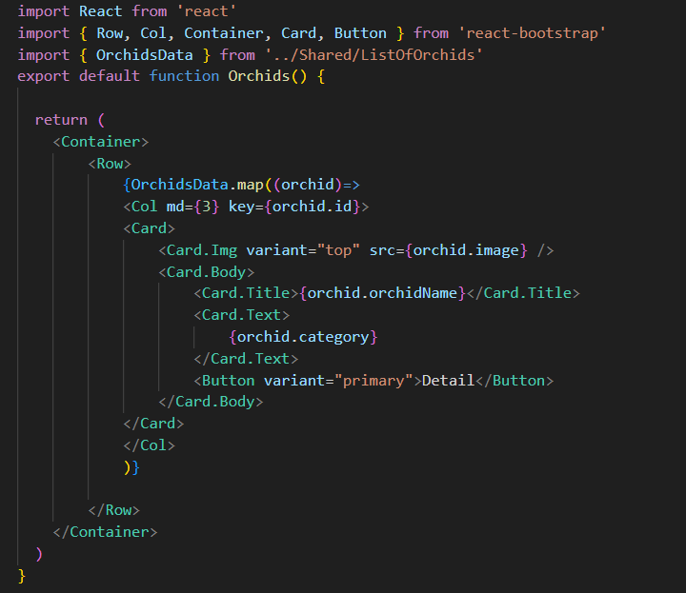

Step 03. Import to App component
import 'bootstrap/dist/css/bootstrap.min.css';
import NavBar from './components/NavBar';
import Orchids from './components/Orchids';
function App() {
return(
<>
<NavBar/>
<Orchids/>
</>
)
}
export default App;
- The screen will display below:
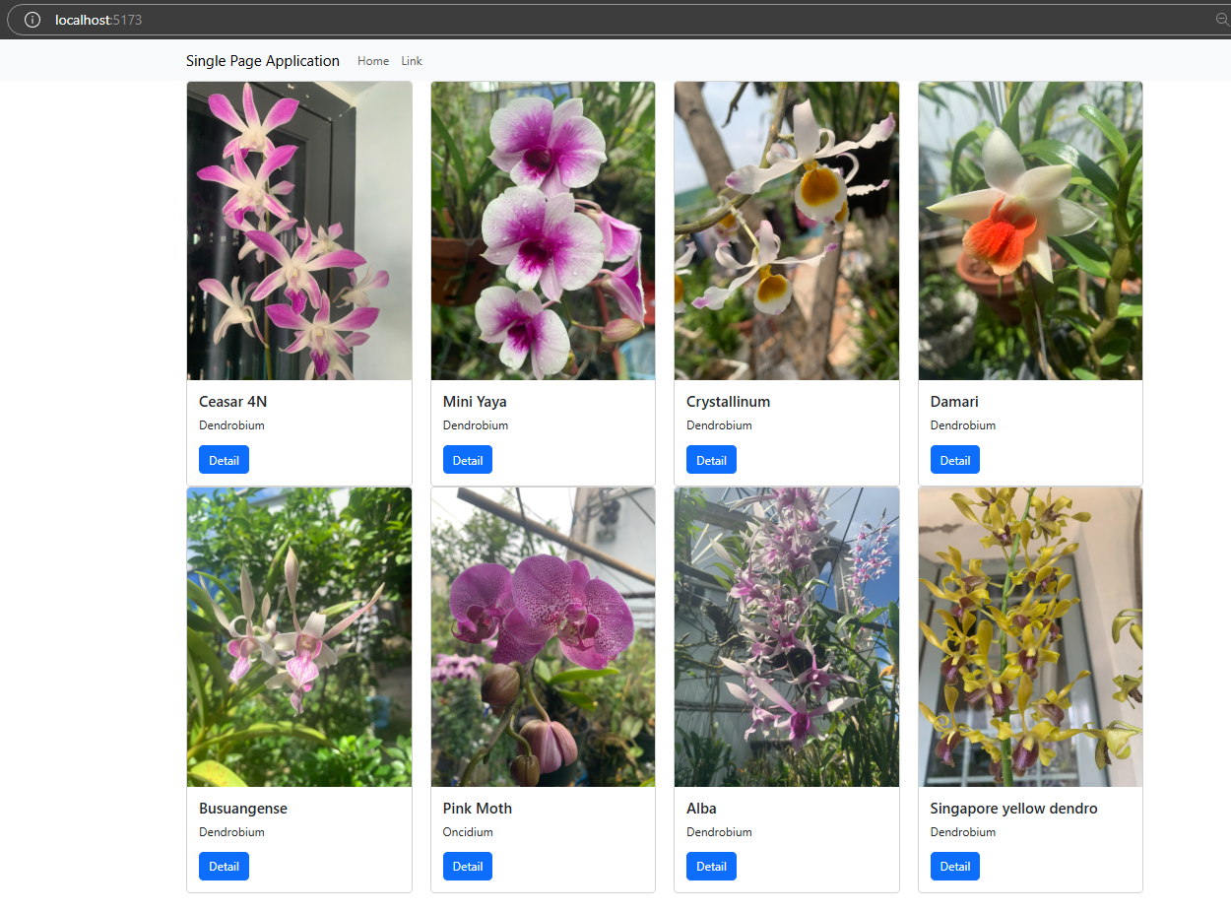

Step 04. Complete the detail of Orchid function
- Update somw code to show the detail of Orchid :
import React, { useState } from 'react'
import { Row, Col, Container, Card, Button } from 'react-bootstrap'
import { OrchidsData } from '../Shared/ListOfOrchids'
import Modal from 'react-bootstrap/Modal';
export default function Orchids() {
const [show, setShow] = useState(false);
const [selectedOrchid, setSelectedOrchid] = useState(null);
const handleClose = () => setShow(false);
const handleShow = (orchid) => {
setSelectedOrchid(orchid);
setShow(true);
}
return (
<Container>
<Row>
{OrchidsData.map((orchid) => (
<Col md={3} key={orchid.id}>
<Card>
<Card.Img variant="top" src={orchid.image} />
<Card.Body>
<Card.Title>{orchid.orchidName}</Card.Title>
<Card.Text>
{orchid.category}
</Card.Text>
<Button variant="primary" onClick={() => handleShow(orchid)}>
Detail
</Button>
</Card.Body>
</Card>
</Col>
))}
</Row>

<Modal show={show} onHide={handleClose}>
<Modal.Header closeButton>
<Modal.Title>{selectedOrchid ? selectedOrchid.orchidName : ''}</Modal.Title>
</Modal.Header>
<Modal.Body>
{selectedOrchid ? (
<div>
<img src={selectedOrchid.image} alt={selectedOrchid.orchidName} style={{ width: '100%' }} />
<p>{selectedOrchid.description}</p>
</div>
) : (
<p>Loading details...</p>
)}
</Modal.Body>
<Modal.Footer>
<Button variant="secondary" onClick={handleClose}>
Close
</Button>
</Modal.Footer>
</Modal>
</Container>
)
}

- The screen will display below:
